**­­­P.B. Ritch Middle School**

**8th Grade Physical Science Syllabus and Guidelines**

Parents and Students,

We are off to a great start and I am very excited about this school year! Enclosed is a little information that is important for 8th graders in Physical Science.

**Flow of the Classroom:** Each day includes a 3-part lesson, the **Opening**, **Work time**, and **Closing**.

Each student is expected to **engage in** and **explore** Physical Science Phenomena. Technology is used on a weekly basis. Students should have access to a working computer. Students are required to **observe, explain,** **elaborate**, and **evaluate data**. Physical Science is an active class. For example, students will be required to **develop** and **create models**, **demonstrate using technology,** **ask questions**, **identify problems**, **analyze, interpret, read, write**, and use **mathematics**. There are projects, labs, video submissions, model designs, **writing reflections**, class discussions, games, and more that require students to **engage** in the subject matter.

**Online Learning:** Both formative and summative assignments in Canvas are requirement for this course and must be completed. Some Canvas assignments will be projects. Students are required to keep up with assignments on a weekly basis. Additional resources and tools will be posted on Canvas as well. Students should have weekly access to a computer or laptop.

**Opening**: This segment of the day is a crucial part of the lesson because it is state driven, and it informs the students of what we are “doing” in class. Parents, you may engage your young scientist at home by asking, “What was the opening for today? How does it relate to what you did yesterday?” The opening includes the following:

1. Physical Science Standards(**Georgia Standards of Excellence**….”GSE’s”)- Curriculum focus found on the Department of Georgia Website: <https://www.georgiastandards.org/Georgia-Standards/Documents/Science-Eighth-Grade-Georgia-Standards.pdf>
2. Target/Essential Questions- Questions that drive the lesson and promote inquiry thinking
3. Warm-Up Activities- Activity preceding work time that gets students curious and engaged in scientific concepts.

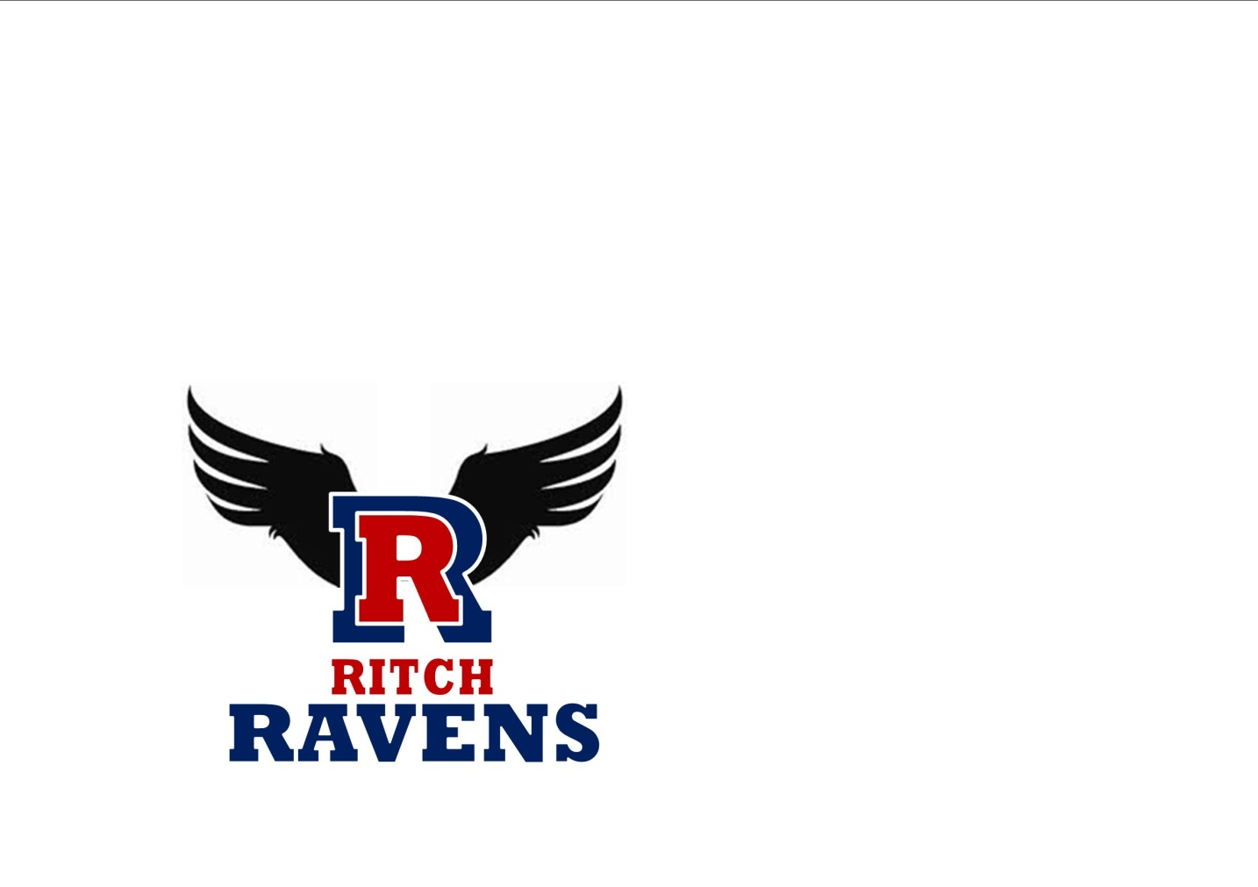 **Work Time:** This is the segment of the class period that includes various activities such as: labs, demonstrations, question/answer sessions, textbook work, note-taking, presentations, reflection discussions, project designs, group work, enrichment, and remediation. You may say to your young scientists, “Show me how your work time activities related to the standard.” Ask, “How does today’s work time activity help you understand your homework for the week?”

**Closing**: This is the segment *throughout* the class period where we check for understanding, and concepts are reinforced. Students are required to reflect on what they learned in class. During this time, students may be given a “ticket out the door” (T.O.D.) which serves as a “check for understanding” opportunity that gives a glimpse of what has been retained. *T.O.D.s are* ***not*** *always announced*, and are sometimes recorded in the gradebook.

**Assessments:** Formative Assessments- 40% assessments (quizzes, check points, handouts, text work, participation, writing reflections, etc). These assessments take place daily. Formative assessments that are recorded in the gradebook weekly. There are no retakes or redos of formative assessments. Exceptions to this are at the teacher’s discretion.

Summative Assessments- 60% assessments (lab reports, major tests, some projects, presentations, cumulative activities, and some writing activities). Standard multiple choice summatives taken at the end of each unit will be given on Tuesdays and/or Wednesdays. These assessments are always announced prior to the date. Summative assessments that are recorded in the gradebook will take place on Tuesdays and Wednesdays. All late summative assessment work will receive minus 20% daily. Due to the nature of lab activities, there are no retakes or redos of lab reports. Exceptions to this are at the teacher’s discretion.

**Tutoring and Test Corrections:** Students must study daily to prepare for Physical science by. Ongoing studying helps to ensure high scores on formative and summative assessments. Students may complete summative assessment corrections during tutoring hours. Students should inform me of when they are coming to tutoring the day before. Students should come prepared with questions and specific concerns. Remember your teacher’s enthusiasm matches his/her students’. When you are engaged in your learning, it makes each experience valuable and a better use of everyone’s time. Tutoring and test correction opportunities take place in room #226 at 7:50 a.m. The mean of the test correction grade along with the original assessment grade will be recorded. There are no retake opportunities for formative assessments unless there is an exception approved by your teacher.

**Late Work:** Students will be required to submit any late formative or summative assignments within 2 school days after a single absence. Thereafter 20% will be deducted daily. Students that score below 79% or lower on summative assessments may make corrections before school and by appointment. The mean of the original and corrected assessment scores combined will be recorded in the gradebook as a final grade for that particular assessment.

**Student Work:** Student projects, models, investigations, and other work may be used to help enrich learning in the classroom for all students. Work not returned home within 48 hours of the due date will be used at the teacher’s discretion.

**Discipline and Attendance:** Students should follow all safety procedures and classroom rules in the classroom. A lab contract must be reviewed and signed before any participation occurs. Discipline steps are followed according to the student handbook. If a student is tardy 3 or more times, disciplinary steps begin. Disciplinary actions include warnings, notes or phone calls home, silent reflection opportunities, working lunches, conferencing, afterschool detentions, writing detentions, team interventions, office referrals, and suspensions (ISS, OSS, and Expulsion).

**Get Reminders and Notifications texted to you!**

Ms. Sigler’s Remind Code Gifted/Advance Class:

Step 1. In your cell phone type 81010 in the recipient box

Step 2. Type **@sciadv2021** in the text message box

Step 3. Click “send”…a welcome message should pop up

Ms. Sigler’s Remind Code **Regular Education Class**:

Step 1. In your cell phone type 81010 in the recipient box

Step 2. Type **@sci8th2021** in the text message box

Step 3. Click “send”…a welcome message should pop up



**Email: ssigler@paulding.k12.ga.us**

**In addition to the supply list on the school’s website you will need the items below for daily supplies:**

A 3-ring binder (at least 2 inches wide), divider pages, a subject spiral notebook (college rule), a ruler, pack of index cards, and 3-hole punch.

**I look forward to a great year!**

**Ms. Sigler**

**­­­**



**P.B. Ritch Middle School**

**8th Grade Physical Science Syllabus**

**SIGN AND RETURN THIS PAGE TO YOR TEACHER!**

**STUDENT NAME AND SCIENCE PERIOD:**

**____________________ __________________________**

**Parent/Caregiver Contact Information: Cell:________________________________**

**Email:_____________________________**

**Extra credit points!!! for each student that returns this page signed and dated. Signatures confirm your acknowledgement and agreement to follow the syllabus and guidelines for Ms. Sigler’s class.**

**Parent Signature__________________________ Student Signature_________________________**

**Date__________________________**

**Student Code (for science class only TBA):_______________________________**